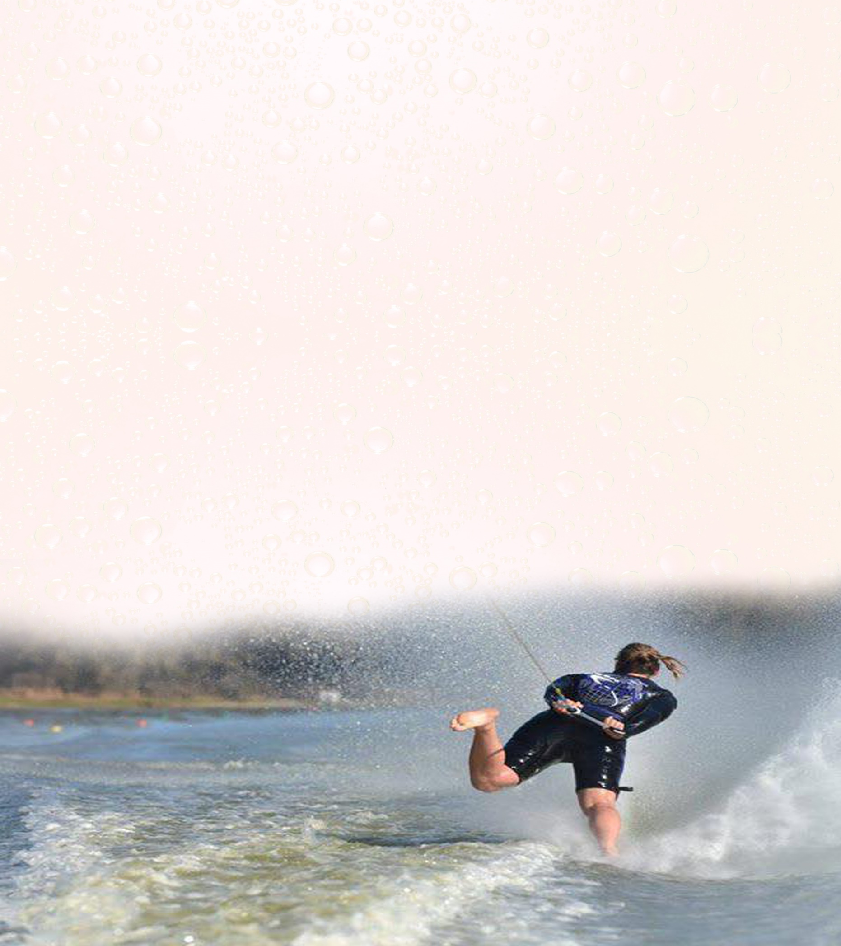
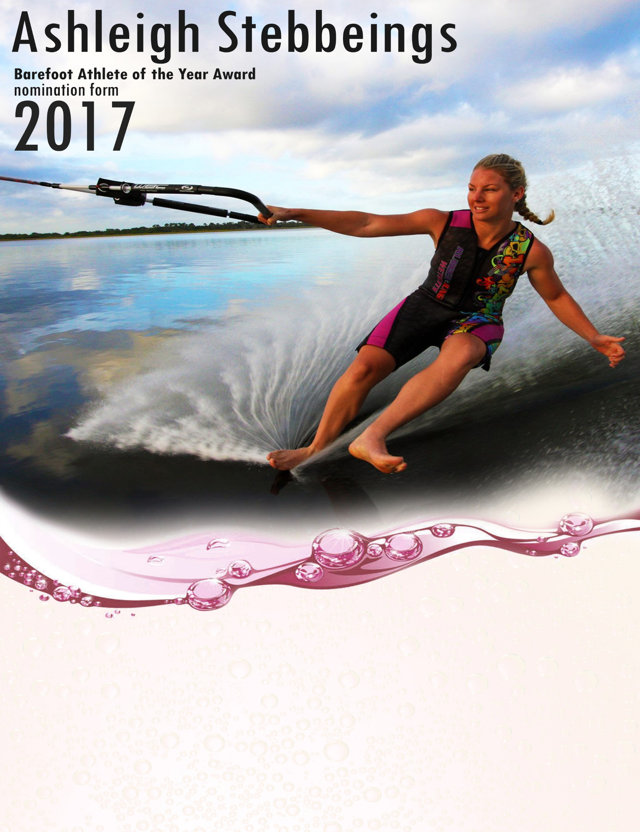

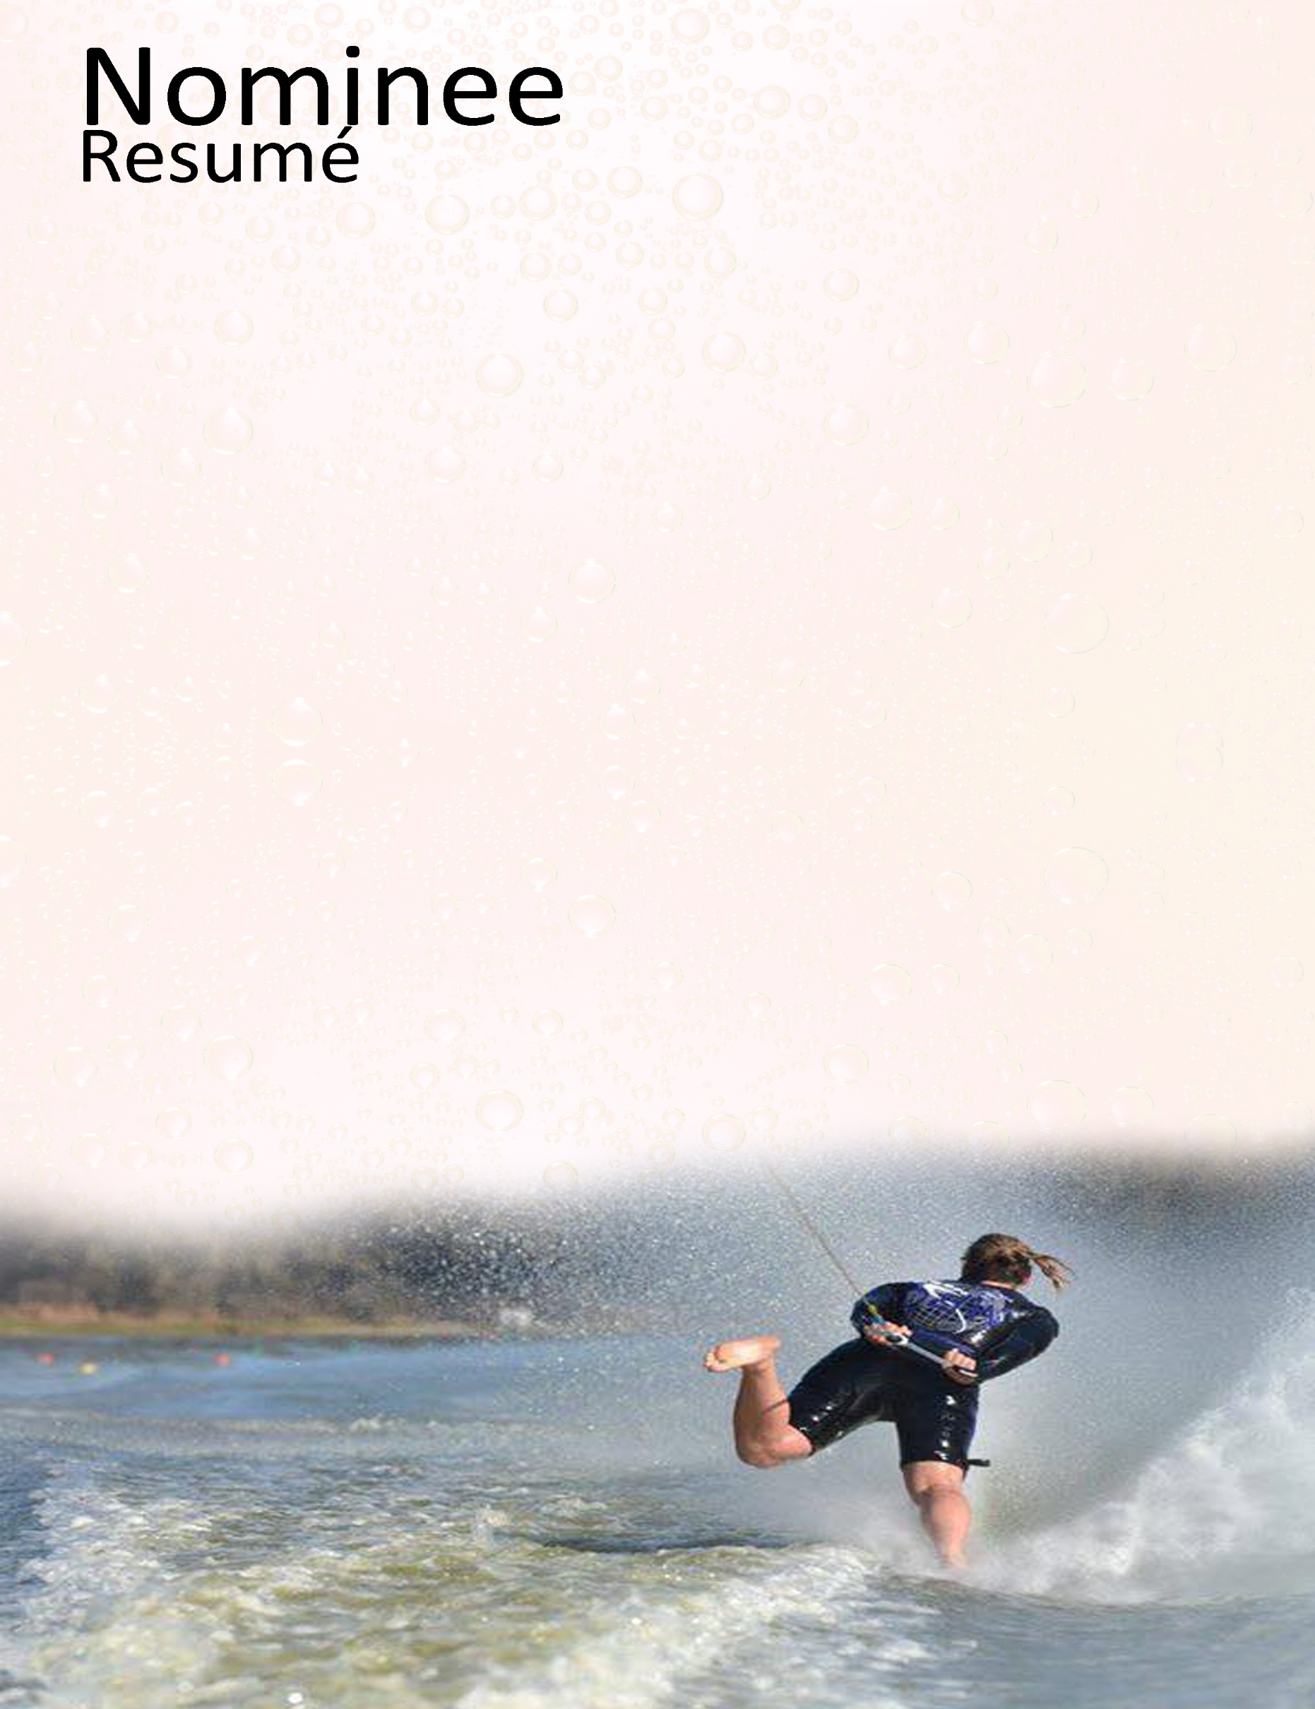
World Records Set:
Set multiple Pending Open Women’s Slalom Records.
Officially broke the Open Women’s Jump Record at 23.4m.
World Championship Performance: N/A
Confederation Championship Performance:
Open Women’s Gold (Overall, Tricks & Slalom)
Open Women’s Silver (Jump)
Major International Event Performance:
Open Women’s International Division Gold (Overall, Tricks, Slalom & Jump)
Number of Tournaments Skied in the Past Year: 6 Three event tournaments & 2 X-Format Events.
Number of International Tournaments Skied in the Past Year: 4 - AO Championships, U.S. Southern Splash, U.S. Southern Regionals & U.S. Nationals.
World Ranking: Ranked #1 in the World in Open Women’s in all 3 events & overall.
Confederation Ranking: Ranked #1 in Oceania in Open Women’s in all 3 events & overall.
National Ranking: Ranked #1 in Australia in Open Women’s in all 3 events & overall.
Confederation & National Records: See above regarding World Records.
2017 Personal Bests Set:
23.5m in Jump

Contributions and Support to Their National Team:
Ashleigh travelled from the U.S. to Australia several times this season in order to continue to support her National Team. She both competed and officiated in the Australian National Championships and AO Championships. Ashleigh ran multiple training clinics throughout Australia, working with skiers of all levels and helping to grow the sport by introducing new recreational skiers to the sport.
World Contributions to the Sport:
Ashleigh has been an Open team member for Australia consistently now since 2004. She has helped to coach several junior teams, as well as spending the U.S Summer in Florida, looking after and coaching junior skiers from all over the world. Aside from skiing, when Ashleigh is not on the water competing she is also a level 2 ranked official. This season she judged at the AO Championship aswell as judged and scored at both the Australian Nationals, U.S Nationals, along with several local and regional tournaments during the U.S summer.
Other important information:
Ashleigh is based out of the World Barefoot Center, in Florida, where she spends her days in the boat coaching and instructing people of all skill levels. This season Ashleigh broke the Open Women’s World Jump Record to 23.4m, pushing the World Record further by 1.5 Metres, previously set by her in 2016 at 21.9m. She became the first female in history to jump over 23m. Ash continues to push the barrier in this sport for female barefooters and is an amazing role model on and off the water for aspiring women barefooters.

