2016 World Barefoot Championships
Lead Officials

Chief Judge - Geoff Blaauw AUS
geoff@responsere.com

Assistant Chief Judge - Mike Molepske USA
mike.molepske@hotmail.com

Chief Scorer - Claire Mowday NZL
claire.w@clear.net.nz

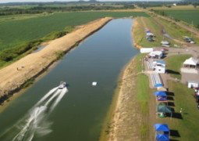
Assistant Chief Scorer - Brian Price AUS
b.j.price@bigpond.com

Homologator - Peter Franks AUS
paflooring@adam.com.au

Chief Video - Rich and Vicky Kaufman USA
Richard Vicky
footer1700@msn.com Vkaufman2014@gmail.com
Chief Driver - Mike Schoenke USA
mschoenke@wi.rr.com

Tournament Director - Paul Adams USA
mnfooter@gmail.com

LOC

LOC Chairman – Cody Heller USA
feet1st2301@gmail.com
LOC Secretary – John Patterson USA
johnpatto123@gmail.com

