International Water Ski & Wakeboard Federation

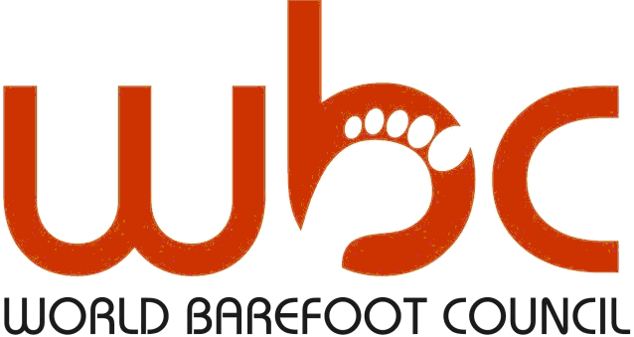

“World Masters Championships” Format
Prepared by
Senior World Championships Committee

February, 2018

Version 6

IWWF World Masters Championships

The technical rules shall be identical to those in the most current WBC Technical Rules with the exception of the modifications to the Technical Rules as stated below:
It is generally understood that any reference to the World Championships shall be applicable to this tournament if appropriate.

Rule 1 - CHAMPIONSHIP EVENTS
1.01: Events
There shall be 3 events: Slalom, Tricks and Jump.
Individual Overall scoring is from either round.
Team scoring is from either round.
1.02: Rounds
All skiers will ski the first round in their divisions seeded in order of the rankings list from the previous 2 years.
All skiers will ski the second round in their divisions seeded in order of their first-round scores. Skiers with no first-round score do not ski in the second round.
The second round is considered to be the final round.
1.03: World Championships Entry and Administration
Deadlines shall be set by the organizer with approval of the Chairman of the IWWF Barefoot Council.
1.04: All skiers must be approved to enter by their federation.

Rule 2 – CHAMPIONSHIP ENTRY REQUIREMENTS
2.01: Team Selection
All federation entries will make up the federation team.
2.02: Skier Eligibility
Skiers eligible for this competition are Men and Women in the age categories listed below.
All ages refer to the age of the skier on the 31st December of the previous year.
Division | Slalom | Tricks | Jump
- 35 – 44
- 45 – 54 |  |  | Separate medal event and not part of overall. Will be able to be calculated in the teams scores.
- 55 – 64
- 65+

Skiers must ski in their age division.

2.03: Minimum number of skiers in a division
3 Skiers skiing in the event for the event to be run.
If only 2 skiers or less enter, then they must enter a lower age group. If only 2 skiers or less enter in 35-44 then 45-54 will combine and jump will be added as an event and tricks and slalom will be the calculation method overall.

Rule 3 - OVERALL AND TEAM SCORING AND COMPETITION
3.01: Overall Scores
Individual overall scores will be calculated by the skiers top score from the two rounds.
Division | Events Included in Overall
35 – 44 | Tricks, Slalom, Jump
45 – 54 | Tricks, Slalom
55 – 64 | Tricks, Slalom
65+ | Tricks, Slalom

Age divisions of 45 and over will have a combined jump event. The scores for this event will not be included in the individual overall scores.
3.02: Team Scoring
Only one score, being the federation’s top score from each division from each event will be used to calculate the team’s results. The score taken will be the thousandised overall score for the division.
This means that if a federation has 3 skiers in a division then only 1 score can be used per event, and a different skiers score per each event (tricks, slalom & jump 35-44) can be used to calculate the team result.
3.03: Team Scoring Single Score From All 8 Division
DIVISION | EVENT
35-44 | 3 | MALE | FEMALE
45-54 | 2
55-64 | 2
65 and over | 2

Rule 4- JUDGES AND ASSISTANTS
4.01: Choosing Appointed Judges
There shall be at least one judge from the two confederations that the championships are not being held in.
4.02: Judges, drivers and scorers may not officiate in the age divisions in which they compete.
4.03: The lead officials will be limited to:
- Chief Judge
- Assistant Chief Judge/Level 1 Judge
- Homologator/Level 1 Judge – non-skier
- Chief Scorer – non-skier
- Two Level 1 Judges – non-skiers
- Chief Driver/Driver – non-skiers
- Chief Video

4.04: The LOC will provide the following for the officials listed in 4.03.
- Accommodation
- Meals each day of the competition, or a meal allowance
- Pick up from the airport
Daily transport will be coordinated by the officials and federation teams.
4.05: The balance of level 1 and 2 officials will be made up by skiers and members of the LOC, with two judges and one driver from each age division. These officials will not be provided with accommodation, meals or airport pick up.
Division | Judges/Scorers | Drivers
35 - 44 years | 2 | 1
45 – 54 years | 2 | 1
55 years and over | 2 | 1
TOTAL | 6 | 3

Rule 5 – NAMES OF CHAMPIONSHIPS
Junior World Championships
Open World Championships
World Masters Championship 35-44
World Masters Championship 45-54
World Masters Championship 55-64
World Masters Championship 65 and over

Rule 6 – X GAMES
5.01: Immediately following the conclusion of the Senior Championships an X-games event will be held.
5.02: Five open division skiers will participate in the event. The balance of the skiers will made up of Senior Division skiers.

This format is still being defined in conjunction with the successful LOC

Rule 7 – SENIOR RECORDS
On the completion of the 2020 World Championships, records for seniors/masters will be listed per the age division in The Records History.

