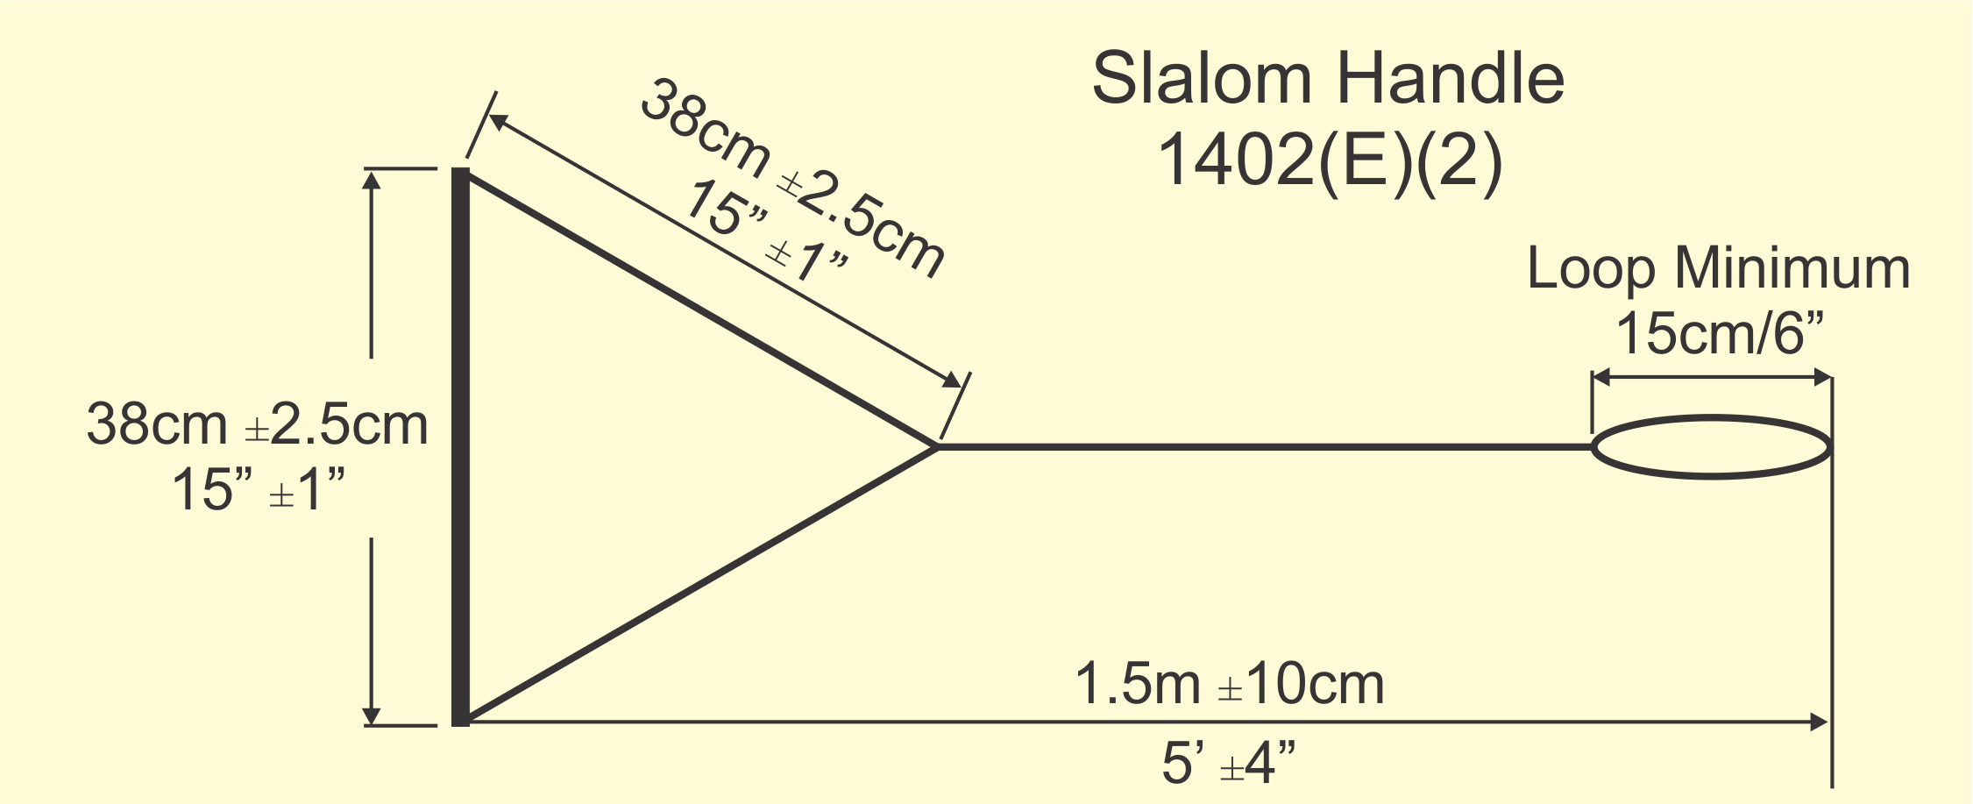

 | Length | Width | Diameter | Loop
Handle 1
Handle 2
Handle 3
Handle 4
Handle 5
Handle 6
Handle 7
Handle 8
Handle 9
Handle 10

1402: Handles
(A) Flotation. Handles shall float or incorporate flotation.
(B) Grip. The handle grip shall be made of 25mm to 28mm outside diameter material with no sharp edges or projections, and with non-slip coating.
(C) Loop. Handles shall be finished with minimum 15cm loop.
(D) Length. The handle and bridle shall have a length of 1.50m ±10cm
(E) Width.
(1) Jump Event. A handle having a width of 30cm ±2.5cm, with a 30cm ±2.5cm length of attached ropes before juncture shall be in the towboat and be the only handle used in the Jump Event.
(2) Slalom and Trick Event. A handle having a width of 38cm ±2.5cm, with a 38cm ±2.5cm length of attached ropes before juncture and a handle having a width of 30cm ±2.5cm, with a 30cm ±2.5cm length of attached ropes before juncture shall be in the towboat.

