INTERNATIONAL WATERSKI AND WAKEBOARD FEDERATION



WWW.WorldBarefootCouncil.com

HOMOLOGATOR CLINIC SYLLABUS
This syllabus is a living document that will be updated at any time as improvements are identified and clinic participants provide valuable feedback. Please send all comments and feedback to:
Oscar Foot Mann: oscarfootmann@hotmail.com
NOTES AND GUIDELINES FOR HOMOLOGATORS
Statement of Purpose
The homologator is in charge of all technical matters at a Barefoot Competition. He is appointed to verify that all the information contained within the dossier is a true and accurate report of what happened at the competition. In the first instance he is responsible to the Chief Judge of the competition, but ultimately he is answerable to the World and/or Region Barefoot Councils. The homologator must ensure and satisfy himself that all technical installations relating to the competition are true and accurate as laid down in the WBC Technical Rules.
At all times, the homologator shall remain in contact with the Chief Judge and they will liase as to what decisions need to be taken.
Any homologator needs to know the homologator’s portion of the rulebook inside out. He must ensure that the technical installations are ready and waiting for the skiers as and when required.
Remember, it is the homologator's duty to check the competition site after it has been set up by the organisers. The homologator is not responsible for the initial set-up nor is he responsible for any corrections that may be needed after the checks have been made.
The homologator must aim for the highest possible standards at all times and for every event. Imagine a skier breaking a record and then discovering that the towline was too long or the ramp was too high or the timer was too slow. Remember: "THE BUCK STOPS WITH YOU - MR HOMOLOGATOR"
Once all the initial checks have been made the job doesn't end there. Constant monitoring and re-checking is the order of the day. Keep a track of what's happened, what's happening and what's going to happen and once equipment has been used it needs to rechecked and made ready again for the next round or next group. If you keep on top of everything you should have no problems.
Record Capability homologation requires prior announcement:
R.C. competitions are the only competitions where Confederation and World records can be established.
The WBC considers that one of its main duties is to provide reliable information to the skiers. Under no circumstances is it allowed to announce that an event is recommended for a class of homologation when the Chief Judge and/or the Homologator believes that the installations or the qualifications of the officials do not meeting the standards for that class of homologation. It might happen that the Chief Judge and the Homologator feel that an event deserves homologation in spite of some requirements not being fulfilled. In such a case, they should announce to the skiers that the event can be homologated to one class of homologation and it is possible that the WBC could upgrade it to another class of homologation after a decision. They should attach a detailed note to the dossier explaining why they feel the higher class of homologation could be granted.
Your ultimate responsibility will be realised when a record is broken. Apart from all the paper-work required, make sure the following criteria are strictly adhered to:
As well as ensuring the correct staffing levels for each event are maintained, all the equipment used for the event must be checked prior to the start of the official familiarization.
Every item on the checklist and worksheet at the end of this document must be completed and recorded and then given to the Chief Judge before the start of the tournament.

Measure Lines and Handles
For all classes of homologation, the Homologator must measure the tournament supplied lines and handles. Dimensions and tolerances are listed in the rulebook and worksheets available on worldbarefootcouncil.com. Remember to have spare toelines, leaders and handles ready in case of breakage.
For all competitions, make sure the official towlines have been stretched before they are measured. It is also highly recommended that the Homologator refuses slalom and jump lines that are longer than the ideal length. Accepting a maximum length line is taking a risk on behalf of the skier of having to deny a Confederation or World record. Remember that a 20 kg load must be applied to the lines and handles when they are being measured.
For Tricks, skiers may provide their own lines and handles of any length and size. In any case, a 21.5 metre homologated tow-line -19.5m towline whenever using 2m leaders – a 30cm and 38cm handle should always be available in the boat during the slalom and trick events.
Courses
For Slalom and Tricks the buoys must be installed as per the rulebook.
The distance to the skier advisory and the driver shut down buoys should be the same distance from each end of the course. Make sure the course buoys are colour coded correctly. The use of large diameter or clusters of buoys is highly recommended for these locations.
For the Jump event, the course must be measured accurately either by using tape measures or a theodolite. The ramp’s physical dimensions must also be checked. Again, it is imperative that the course and buoys are aligned properly and that the course is at 90º to the front edge of the ramp. There should be at least 200 metres of run in to the course. The jump course and video buoys should be brightly coloured and all of the same size.
Boats and Speedometers
Only boats that meet the requirements set out in Chapter 15 in the WBC rulebook may be used for ranking list or record capability competitions. The WBC has a pre-approved boat list to assist homologators. GPS speed measurement is required for the driver. 1 speedometer must be facing the judge(s). The homologator must also verify with the Chief Driver the maximum boat speed possible with a full crew aboard and a 175lb/80kg skier in tow. Check that the boat can reach the maximum required speed (72 kph) by the time the boat passes through the skier advisory buoy line of the slalom and tricks course and the entry gate of the jump course
Wake and Trim Settings
There can be some variation in the wake definition of tow-boats, therefore in order to maintain the same wake definition for each and every skier, the homologator must check that the wake definition and top speed of the boat are as per the rulebook with a full crew on board
Timing Devices
The auto-timer should be checked against a stopwatch.. Once they have been checked and noted on the dossier, the homologator should mark all timing devices.
The auto-timer must be mounted in the boat so that when the horn sounds it can be clearly heard over the engine noise by the judges.
Video
For record capability competitions all slalom, trick and jump passes must be recorded on a current world standard technology, such as but not limited to DVD, memory sticks, SD cards, the internet, etc. which must be made available to the Chief Judge on his request. It is now requested that the Chief Judge be solely responsible for the official video of the competition. It is also imperative that the appointed video personnel should have sufficient media memory and power supplies sufficient for that event/grouping of the competition.
In the case of a record being broken it is the homologator’s responsibility to ensure that a recording showing the record accompanies the completed homologation dossier and judges sheets when it is sent to the committee chairman
For slalom and tricks it is mandatory that the video is located in the towboat in order to give a picture as close as possible to the vision of the judges.

Jump measurement using the Video Measurement system.
See the WBC PPG for approved systems. The Homologator should ensure that the system operator is in direct communication with the towboat, Chief Judge and Chief Scorer at all times during the jump event. The homologator must satisfy himself that the system is reading correctly by physically measuring a test buoy with tape and comparing the result with the distance from the video system.
In the event of a jump record the homologator must ensure that the metered jump landing image and the course set-up is saved to memory and forwarded to the record review committee immediately following the tournament. An image from the same camera set up of the video distancing buoys with no jumper should also be saved and forwarded in case a buoy is obscured in the landing frame.

Records
If the score given for a jump is a record, the Homologator shall make a visual positioning check of the ramp using the course buoys or indicators on shore so that he can confirm that the ramp has not moved from its homologated position.
The competition does not have to stop for checking the course or ramp dimensions, which the Homologator is constantly monitoring from the shore using the water-line indicators on the top and front. He will have stopped the event if the ramp was out of tolerance.
Nor does the rope and handle need to be re-certified and checked by the Homologator immediately following a record performance. It was certified before it entered the boat. This applies equally to all events.
The Homologator shall be responsible for the on site scrutiny of all potential records.

AFFIDAVIT—CLAIM DOCUMENTATION
Review in Descending Order. All performances in all record eligible rounds equal to or exceeding the existing record shall be put forward, and reviewed in descending order until the best that can be verified is established.

While only one record can be set in any event during a tournament it must be stressed that what the scrutiny committee feels is the highest scoring record may fail at the Record Review Committee (RRC) so any and all performances that still exceed the existing record after scrutiny must be submitted to the RRC.

The scrutiny committee need not be the event judges. The most qualified officials available shall review the claim and all details as per the requirements set forth in the WBC rulebook while at the tournament. Whenever possible, the Confederational Record Review Committee member should be included in the review of the claim before submission to the RRC Chairman. If this reviewing panel is satisfied that it’s valid and the paperwork is in order, the claim shall be put forward.

A Scrutiny Committee must review all potential records onsite before the record is forwarded to the WBC or Federation Records Committee. The Homologator or Chief Scorer shall advise the CVO of all potential records as soon as possible. Copies shall then be made of potential records from the event media for the sole purpose of record review. This will allow review and ratification of records to proceed without interfering with the ongoing tournament. . Record review can be done at slow speed and the committee members are allowed to discuss their opinions. Scores derived by the scrutiny committee are not the scores to be used for tournament placement. The scores that were adjudicated by the event judges must be used for tournament placement.

The Chief Judge of the World Championships shall provide the Skier or Team Representative all evidence and documentation necessary for substantiating any pending Federation or Confederation record set at the World Championships.

The Team Representative and any of his Confederation Council or WBC Members shall also be afforded the facilities to scrutinize the pending Confederation or Federation record or make record verification.

The Homologator or Chief Judge shall provide the skier or team rep whatever is necessary for Federation or Confederation record review. If members of the skier’s Federation or Confederation Council or record review committee are present they shall be allowed to view the pending record as well as the team rep for the skier.

Homologation Worksheet
Tournament Name: ______________________ Dates: ____________
Tournament Director: ____________________ Chief Scorer: _____________________ Level _____
Chief Judge: ___________________ Level _____ Chief Driver: _____________________ Level _____
Homologator: _____________________ Level _____
- Download Homologation work sheets from woroldbarefootcouncil.com
- Check, identify, record rope, leader and handle measurements
- Check quick connect devices on leaders
- Check boats comply with 1501(C) or are on WBC pre-approved towboat list
- Check and record rope attachment point heights
- Check boats for top speed as per 1503. Advise CJ of top speeds as per 1502
- Check speed control devices
- Check speed-recording devices are present in the boats. Make sure rear-facing speed is readily readable.
- Check Slalom and trick course and record on worksheet
- Check jump course measurements and record on worksheet
- Check jump ramp measurements and record on worksheet
- Verify video jump buoy coordinates via survey or measurement.
- Verify that lowest and highest readable distances are within necessary parameters to measure lowest and longest probable jumps as verified by the World Rankings List.
- Check video jump program homologation levels requirements are met.
- Shoot a test distance with rope or tape measure and verify with computer
- Ensure a list all necessary records (World, Confed, Fed, State) is posted for computer operators and scorers
- Fill out Homologation Notice form, CJ and Homologator sign and post
Homologator Signature: _______________________ Email: _______________________________

Timers, Handles, Ropes
Audible Timing Device [1405]
[ ] Majority Timer. A timing device that provides three operating switches.
[ ] Instantaneous Timer. A timing device with a single operating switch.

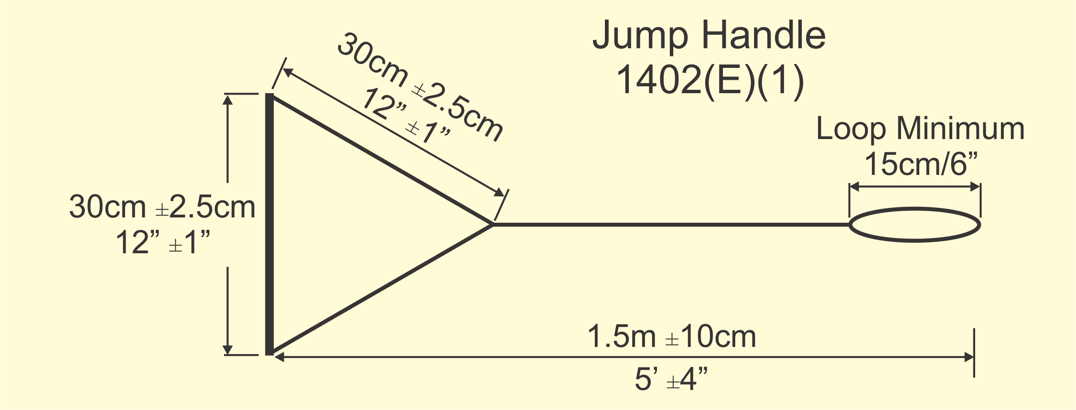
 | Length | Width | Diameter | Loop
Handle 1
Handle 2
Handle 3
Handle 4
Handle 5
Handle 6
Handle 7
Handle 8
Handle 9
Handle 10

Jump Handles
Flotation. Handles shall float or incorporate flotation. Grip. The handle grip shall be made of 25mm to 28mm outside diameter material with no sharp edges or projections, and with non-slip coating. Loop. Handles shall be finished with minimum 15cm loop. Length. The handle and bridle shall have a length of 1.50m ±10cm Width. A handle having a width of 30cm ±2.5cm, with a 30cm ±2.5cm length of attached ropes before juncture shall be in the towboat and shall be the only handle used in the Jump Event.

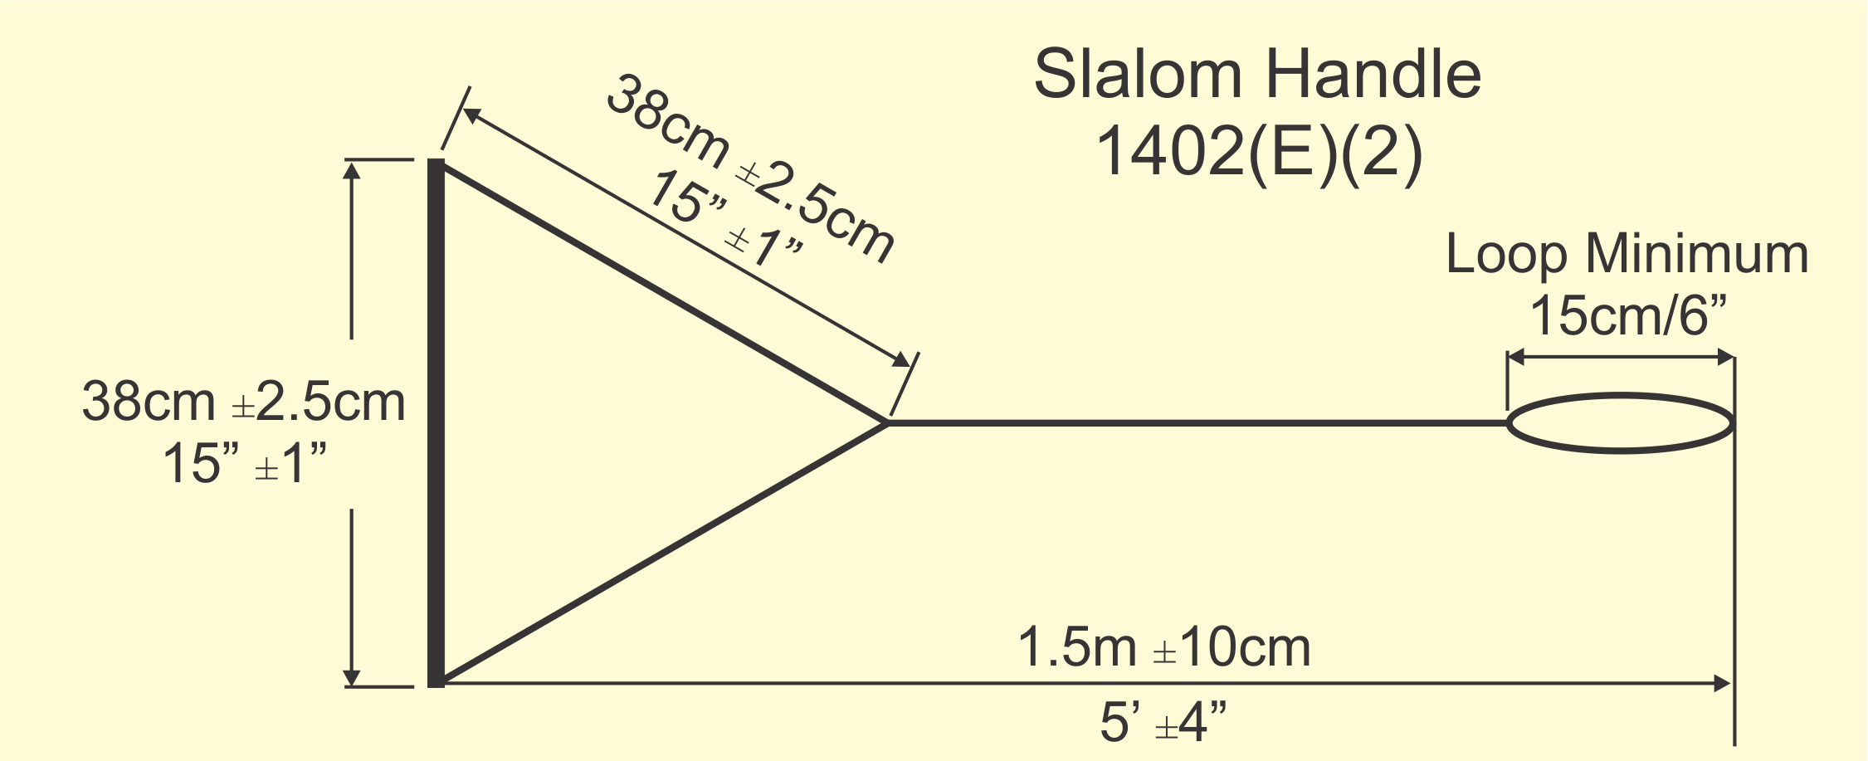
 | Length | Width | Diameter | Loop
Handle 1
Handle 2
Handle 3
Handle 4
Handle 5
Handle 6
Handle 7
Handle 8
Handle 9
Handle 10
Slalom/Trick Handles
Flotation. Handles shall float or incorporate flotation.
Grip. The handle grip shall be made of 25mm to 28mm outside diameter material with no sharp edges or projections, and with non-slip coating.
Loop. Handles shall be finished with minimum 15cm loop.
Length. The handle and bridle shall have a length of 1.50m ±10cm
Width. A handle having a width of 38cm ±2.5cm, with a 38cm ±2.5cm length of attached ropes before juncture and a handle having a width of 30cm ±2.5cm, with a 30cm ±2.5cm length of attached ropes before juncture shall be in the towboat.

 | Mainline Length | Attachment Loop | Handle Loop |  | Leader Length
Rope 1 |  |  |  | Leader1
Rope 2 |  |  |  | Leader2
Rope 3 |  |  |  | Leader3
Rope 4 |  |  |  | Leader4
Rope 5 |  |  |  | Leader5
Rope 6 |  |  |  | Leader6
Rope 7 |  |  |  | Leader7
Ropes
Stretch. Ropes shall be made from a low-stretch plastic or similar material and have been sufficiently pre-stretched so as to allow only minimal stretch.
Rope Fittings.
(1) A lightweight fitting approved by the Chief Judge for easy attachment of leaders, ropes, or handles shall be permitted for any event.
(2) Metal clips shall not be used in the jump event.
Junctures. Junctures in lines shall be by splicing or threading of adequate length to prevent slippage, and reinforced where necessary by knotting, stitching or binding.
Measurement. Measurements of ropes and handles shall be made with 20 kg (44 lb) of tension and shall be between the center of the handle grip (or inside of rope loop) and the inside of the rope loop at the other end.
Chapter 15: Towboats
Boat Specifications [1501]
Towboats containing required boat officials obtains 72 kph/44.7 mph by the entry gate for the Jump Event and skier’s advisory buoy for the Trick and Slalom Event while towing a 80k/175 lb barefoot skier.
Top speeds attained during pre-tournament testing
Boat number or description Top Speed
Points of Attachment
[ ] Mandatory Lower Attachment Point. 1m +/- 25 cm.
[ ] Mandatory Middle Attachment Point. 2m +/- 50 cm.
[ ] Optional High Attachment Point. 4m +/- 50 cm.
Speed-Measuring Devices
[ ] At least one GPS speed measuring device.
[ ] GPS visible to the Driver.
[ ] One speed-measuring device visible to Event Judge when facing aft.
[ ] One tachometer

Jump Course
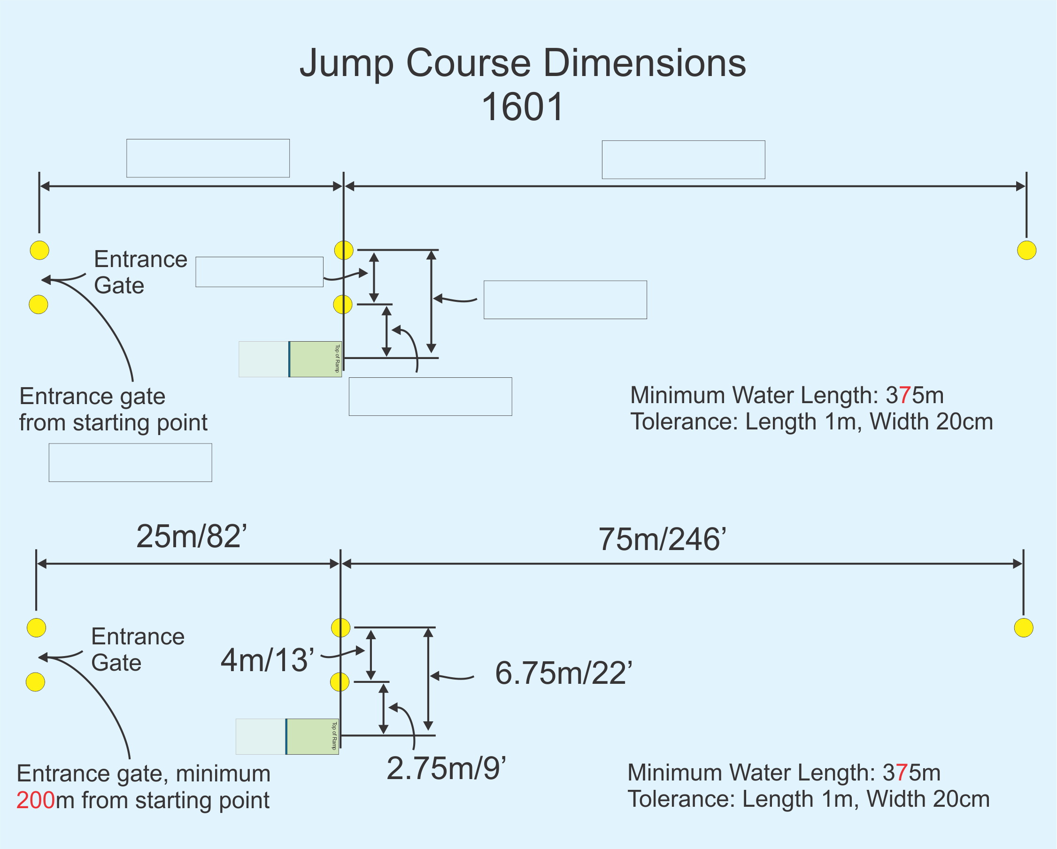
Slalom and Trick Course
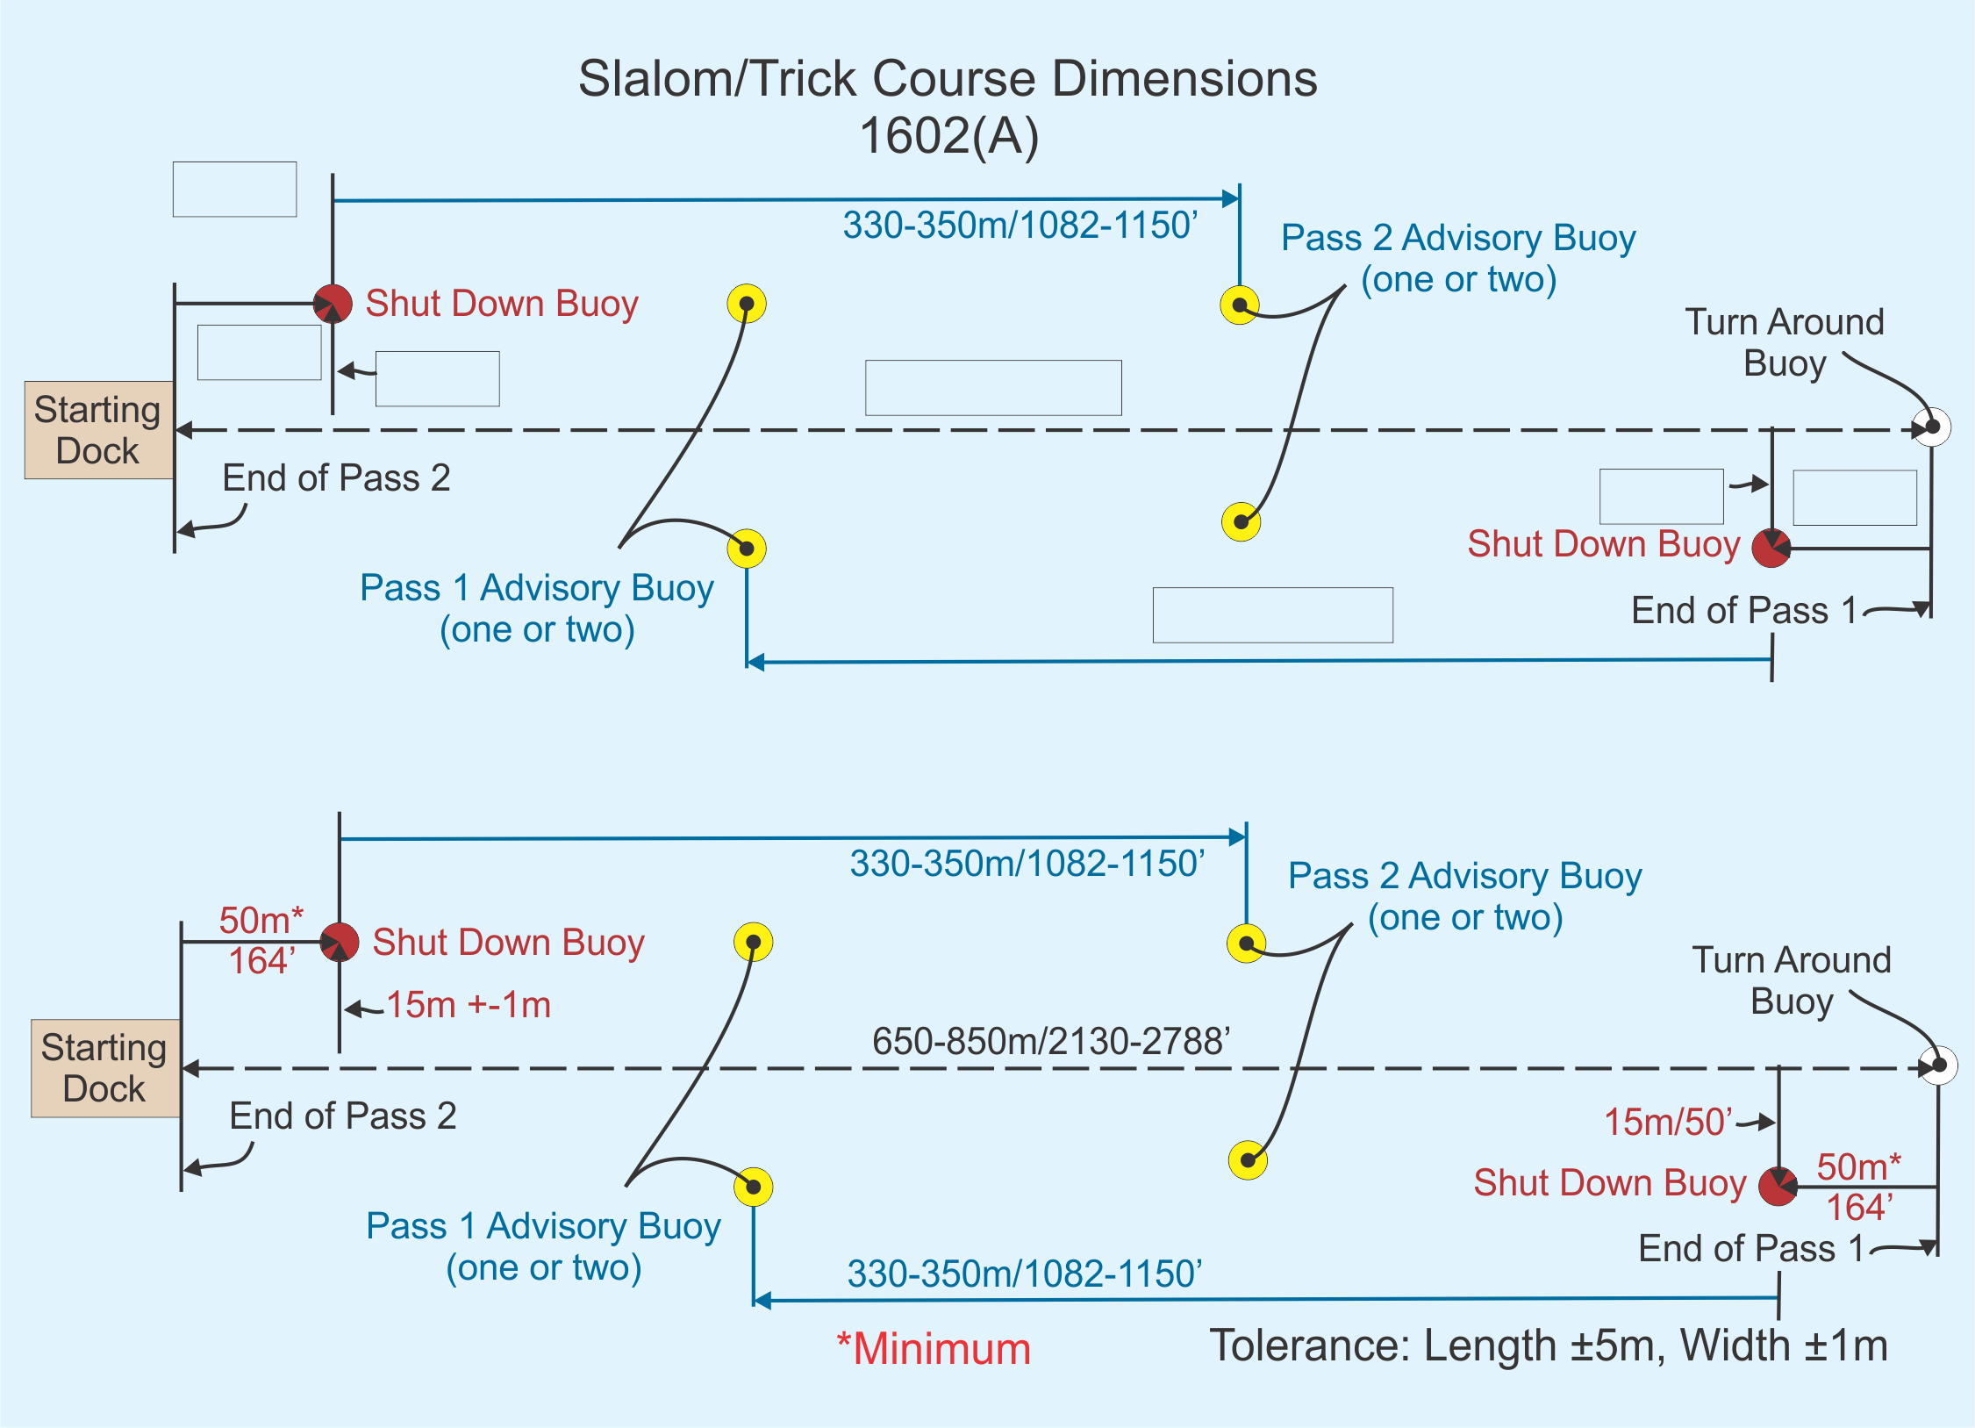
[ ] Dock allows skier to take more than one hop, skip or step on the dock before a dock start located near the extension of the course line.
[ ] Tower allows skier to take more than one hop, skip or step on the dock before a dock start between 2.5m - 5m above the water surface.
[ ] Course lines for the two passes coincide where possible.
[ ] Shutdown buoy is of a contrasting color to the skier advisory buoys.
Jump Ramp

Overall ramp length _____.
Width of surface-tolerance marking the waterline line. __________
Length of ramp surface to center of marked water line ___________.
Actual length of exposed ramp surface _________
Width of height-tolerance waterlines _________
Actual height at top of ramp from water _________
Width of ramp ___________

Note:
- Ramp is a dark color below and a light color above the waterline
- Verify video jump buoy coordinates via survey or measurement.
- Verify that lowest and highest readable distances are within necessary parameters to capture the lowest and highest jump scores entered in the tournament.
- Check video jump program homologation levels meet tournament requirements.
- Shoot a test distance with rope or tape measure and verify with computer
- Ensure a list of all necessary records (World, Confed, Fed, State) is posted for scorers and computer operators
- Fill out Homologation Notice form, CJ and Homologator sign and post

HOMOLOGATION NOTICE
To be posted prior to the official Start time of the competition
Name of competition: __________________________________________________________
Venue: _____________________________________________________________________
Federation: __________________________________________________________________
Chief Judge: _____________________ Homologator: __________________________
Signed: __________________________ Signed: ______________________________
Date _____________________________________________________
Time _____________________________________________________
_____________________________________________________________________________
We recommend to the WBC the following class of homologation:
Slalom Tricks Jump
Not Homologated � � �
Rankings List � � �
Record Capability � � �

Note: These recommendations may change during the competition.

Remarks

_____________________________________________________________________________

_____________________________________________________________________________

_____________________________________________________________________________

_____________________________________________________________________________

____________________________________________________________________________________________

