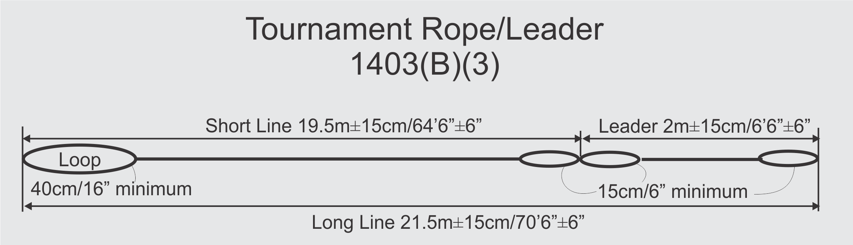

 | Mainline Length | Leader Length | Attachment Loop | Handle Loop
Rope 1
Rope 2
Rope 3
Rope 4
Rope 5
Rope 6
Rope 7
Leader 1
Leader 2
Leader 3
Leader 4
Leader 5
Leader 6
Leader 7
Leader 8
Leader 9
Leader10

Ropes
Stretch. Ropes shall be made from a low-stretch plastic or similar material and have been sufficiently pre-stretched so as to allow only minimal stretch.
Rope Fittings.
(1) A lightweight fitting approved by the Chief Judge for easy attachment of leaders, ropes, or handles shall be permitted for any event.
(2) Metal clips shall not be used in the jump event.
Junctures. Junctures in lines shall be by splicing or threading of adequate length to prevent slippage, and reinforced where necessary by knotting, stitching or binding.
Measurement. Measurements of ropes and handles shall be made with 20 kg (44 lb) of tension and shall be between the center of the handle grip (or inside of rope loop) and the inside of the rope loop at the other end.

